Broadchurch season 3 spoilers, cast, trailer, location, air date - everything you need to know

David Tennant and Olivia Colman are reunited one last time...

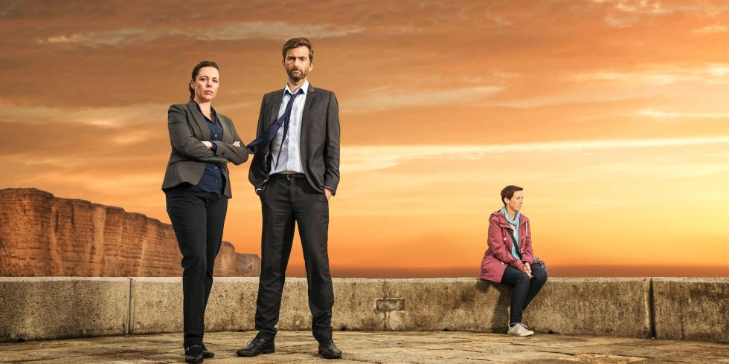

They've been through more pain and heartache than Bambi and Droopy put together, but Alec Hardy and Ellie Miller are back for a third - and final - series of Broadchurch.

But how will the ITV thriller's swansong unfold? Surely the Latimers and their fellow Broadchurch residents can only handle so much? Here's everything there is to know so far.

Broadchurch release date: When does it air?

Broadchurch series three kicked off on February 27 on ITV and will continue Mondays at 9pm.

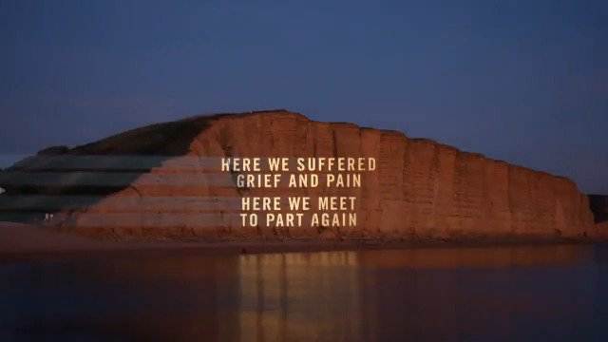

Broadchurch spoilers: What is the plot of series 3?

While the second series focused on Alec Hardy's past as well as the Joe Miller court case, series three will be centred on an entirely new crime.

Hardy and Miller are investigating a serious sexual assault that takes place in Broadchurch, and the emotional damage it causes everyone connected to the crime and the victim.

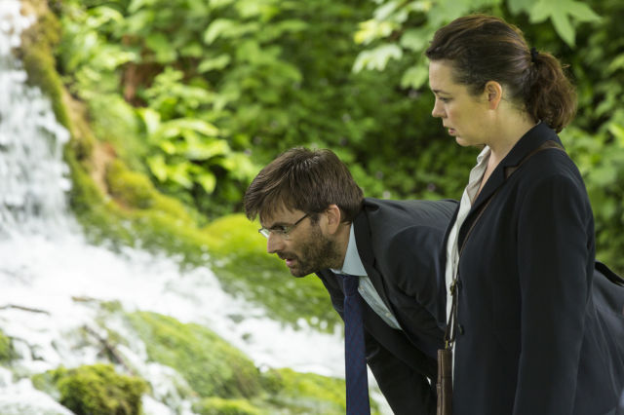

Episode one saw Hardy and Miller help Trish through her initial trauma... and already we have some clues as to who the chief suspect might be. Did you notice that the condoms in dodgy Jim Atwood's car were the same brand as found on the crime scene?

Episode two and the plot thickened. Trish's ex-husband Ian (Charlie Higson) refused to hand over his DNA to the cops - is he her attacker? Jim's still a suspect, as is creepy cab driver Clive Lucas (Sebastian Armesto).

Episode three saw Clive emerge as chief suspect, after it was revealed that he has Trish's key fob. But Ian's not in the clear either - he lied to the police about how he got home from Cath's party.

Episode four introduced convicted rapist Aaron Mayford (Jim Howick) - he might now be the most obvious suspect, but he's far from the only name still on Hardy and Miller's list...

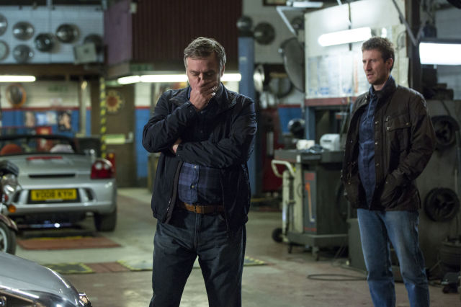

Ian's girlfriend confessed to sending Trish those threatening texts, but Ian himself (Higson) is still working to clear something dodgy off of his laptop. Meanwhile, Jim (Mark Bazeley) was revealed as the man that Trish slept with the morning before her attack, but his alibi ("If I wanted to have sex with her, I could.") isn't much of one.

Ed (Lenny Henry) may no longer be a suspect - Trish's attacker had been drinking vodka, which would appear to rule out the tee-total shopkeeper. She also remembered a light shining down on her - possibly from a camera phone? Was her attack filmed?

Creator Chris Chibnall and his team have worked on series 3's plot with Dorset-based organisations who specialise in helping victims of sexual assault, as well as police advisors who deal with crimes involving sexual violence.

But with several characters from series one returning, Joe Miller's murder of Danny Latimer and subsequent acquittal will no doubt remain an ongoing theme running through the heart of the drama.

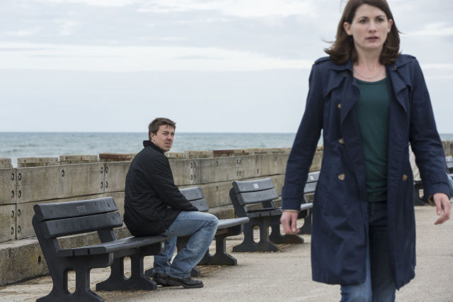

Arthur Darvill told us that series three will see the show go back to its roots.

"This series, I think, is just going to be brilliant," he enthused. "I can't tell you too much about it, but the subject matter of it is really heavy.

"I loved the second series of Broadchurch - I think it was really necessary to tell that part of the story - but I think this series has more of the feel of the first series."

Darvill told us that he was "in and out" of the show's summer shoot, so you can expect him to "pop up... every now and then".

The first teaser trailer was unveiled in late December 2016, and it features what you've come to expect: David Tennant brooding at sea.

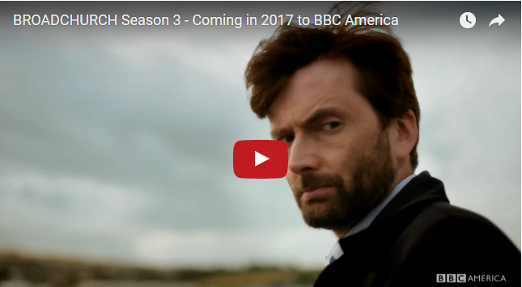

A second, extended trailer debuted in late January 2017 - with Hardy and Miller tackling what looks to be their darkest case yet.

Broadchurch cast: Who's coming back?

David Tennant and Olivia Colman reunite once more as Hardy and Miller, and they'll be joined by several other characters from the first two series.

Arthur Darvill is back as dependable vicar Paul Coates, along with Carolyn Pickles as newspaper editor Maggie Radcliffe and Adam Wilson as Ellie's son Tom.

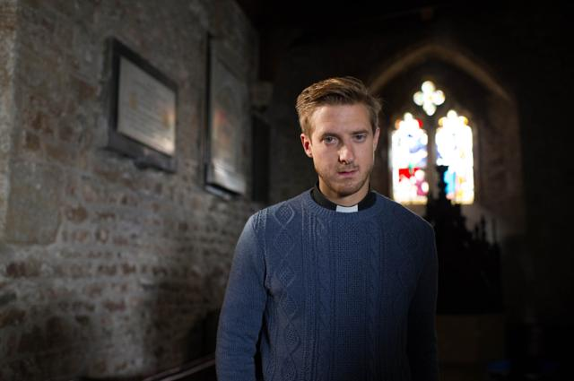

Jodie Whittaker and Andrew Buchan are also back one more time as long-suffering husband and wife Beth and Mark Latimer, along with Charlotte Beaumont as daughter Chloe.

Hannah Rae returns as Hardy's 17-year-old daughter Daisy, but it's yet to be confirmed if other regulars will be back, including Lucy Cohu as Alec's ex-wife Tess, Tanya Franks as Lucy Stevens or Jonathan Bailey as Olly Stevens, nor any word on series two newcomers Eve Myles (Claire Ripley) or James D'Arcy (Lee Ashworth).

Broadchurch cast: Who are the new additions?

National treasure Lenny Henry is arguably the biggest new addition to the drama, as shopkeeper Ed Burnett, a suspect in the serious sexual assault case.

Coronation Street legend Julie Hesmondhalgh continues her TV takeover after Happy Valley, joining the series as rape survivor Trish Winterman.

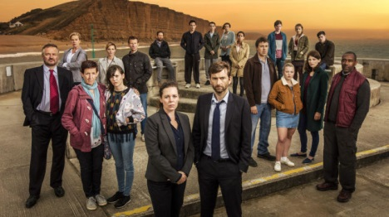

Fellow soap star Sunetra Sarker (Casualty) will also have a leading role as a colleague and close friend of Jodie Whittaker's Beth.

The Fast Show star Charlie Higson plays teacher Ian Winterman, Cutting It actor Sarah Parish is Trish's friend Cath Atwood, Home Fires' Mark Bazeley is Cath's husband Jim, BAFTA winner Georgina Campbell plays feisty DC Katie Harford, comedy veteran Roy Hudd plays David Barrett and Poldark's Sebastian Armesto is taxi driver Clive Lucas.

Holby City's Tina Hobley was apparently in line for a role, but was forced to drop out due to injuries sustained while taking part in The Jump.

She told Hello: "I couldn't make it because I was in plaster. I'd been waiting two years for that job."

Broadchurch locations: Where is it filmed?

As with the previous two series, Broadchurch's third run is being shot on location in Dorset. It also returned to several locations within Bridport, West Bay and Clevedon

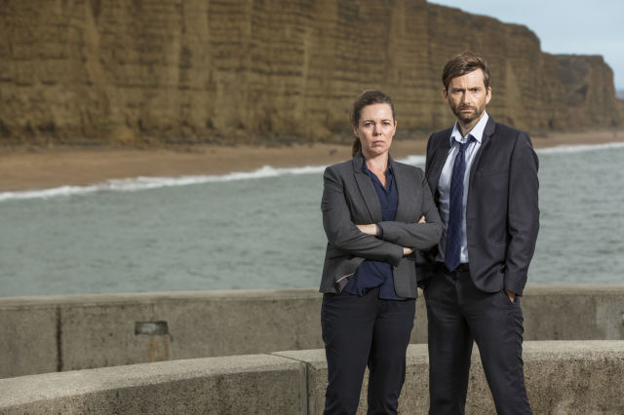

Broadchurch series 4... or is this definitely be the end?

Most likely. ITV has stated that this will be the final series to complete a trilogy - and a spin-off has also been ruled out. Though, you never know.

The main reason behind its end is Chibnall's future job as Doctor Who showrunner from 2017 onwards. He'd be a very busy boy if he tried to juggle two shows at once - just ask Steven Moffat.

